Meeting name: KUTC Steering Committee (SC) Meeting | Time | 10:30 ~ 11:30 am  (UAE time)
Location: Video Conference (MS Teams)
Date: Thursday, 28 October 2021

Attendees
KBSI | KU
Dr. Hae Jin Kim, Director of KUTC (KBSI) | Prof. Daniel Choi, Director of KUTC (KU)
 | Dr. Jérémie Pelletier, Lab acting director (Manager of KUTC)

Agenda Items
- Final preparation of KUTC office and lab.
- Progresses and achievements for the first-half of 2021 (KBSI, KU).
- Research equipment support plan
- Proposed change in status of KUTC
- Final preparation of new KUTC office and lab:
- Research and Office space preparation
1. Office space is located at Arzanah in SAN campus and basic furniture is ready.
2. Electrical work for the research space is still in progress, and there is a delay in completioin of retrofitting the lab due to the UAE ADDC approval problem, but it is expected to be resolved in early November or later.
- Progresses and achievements for the first-half of 2021 (KBSI, KU).
- Ongoing project and new project support
- KUTC research project “Development of solid electrolytes for harsh environment” is in progress (Project period: Nov. 2019 -Oct 2022.
- Hydrogen mobility research project between the Korean and UAE governments is in progress. KUTC has been requested by Korea government to be engaged in the project. The Korea Transport Institute(KOTI) with the working group will visit the UAE in mid-November to hold a workshop with KUTC.
- Request for dispatch of research equipment experts for Khalifa University
- Issue of relocation impact on Core lab operation
- Aiming for full operation in the Q1 2021 (The Analytical Chemistry and Biochemistry Core (ACBC) Laboratory, The Solar and Device Characterization Lab, The Materials Testing Laboratory
- Dispatch of research equipment experts
- Support from KBSI experts for KU Clean Room and Electron Microscopy facilities would be very helpful.
- Etching system and testing equipment are required to be operated. In particular, for semiconductor-related equipment, expert in the area of a vacuum system is the most necessary.
- KU requests to dispatch research equipment experts who can consult Electron Microscopy, TEM and XPS experts. (KBSI staff are planning to visit in November, so I will make a related investigation at that time and find a way to cooperate).
- KU suggested either KBSI’s on-line or off-line traning session(s) on XPS for KU reseaerchers including students, if feasible.
- Proposed change in status of KUTC
- Proposal to change the name of the KUTC center to a joint lab
- 1. Human resource exchange with professors, students, and researchers is valid
- Requires approval from both governments
1. KUTC was resukted from the agreement between Korea government (Ministry of Science & ICT), UAE government (DED). Therefore, changing the center to the lab requires approval from the both government.
2. Changing the name of KUTC is not a simple matter because the names of KOREA and UAE include national names.
3. Korean government (Ministry of Science and ICT) should be aware that the UAE government R&D budget for science and technology was reduced. Accordingly, budget for Korea side may need to be reduced.

Action Items
Relocation of KUTC office and lab
- Electrical work will be proceeded without a hitch by early November and the approval will be completed.
Research equipment support plan
- KBSI-KU are considering dispatching experts with the goal of the Q1 2021 for the restart of the research lab.
- KBSI will actively cooperate with the dispatch of vacuum experts to build a new clean room and support XPS and EM equipment. KBSI will visit KUTC to find out the demand for research equipment in early to mid-November 2020.
Proposed change in status of KUTC
- 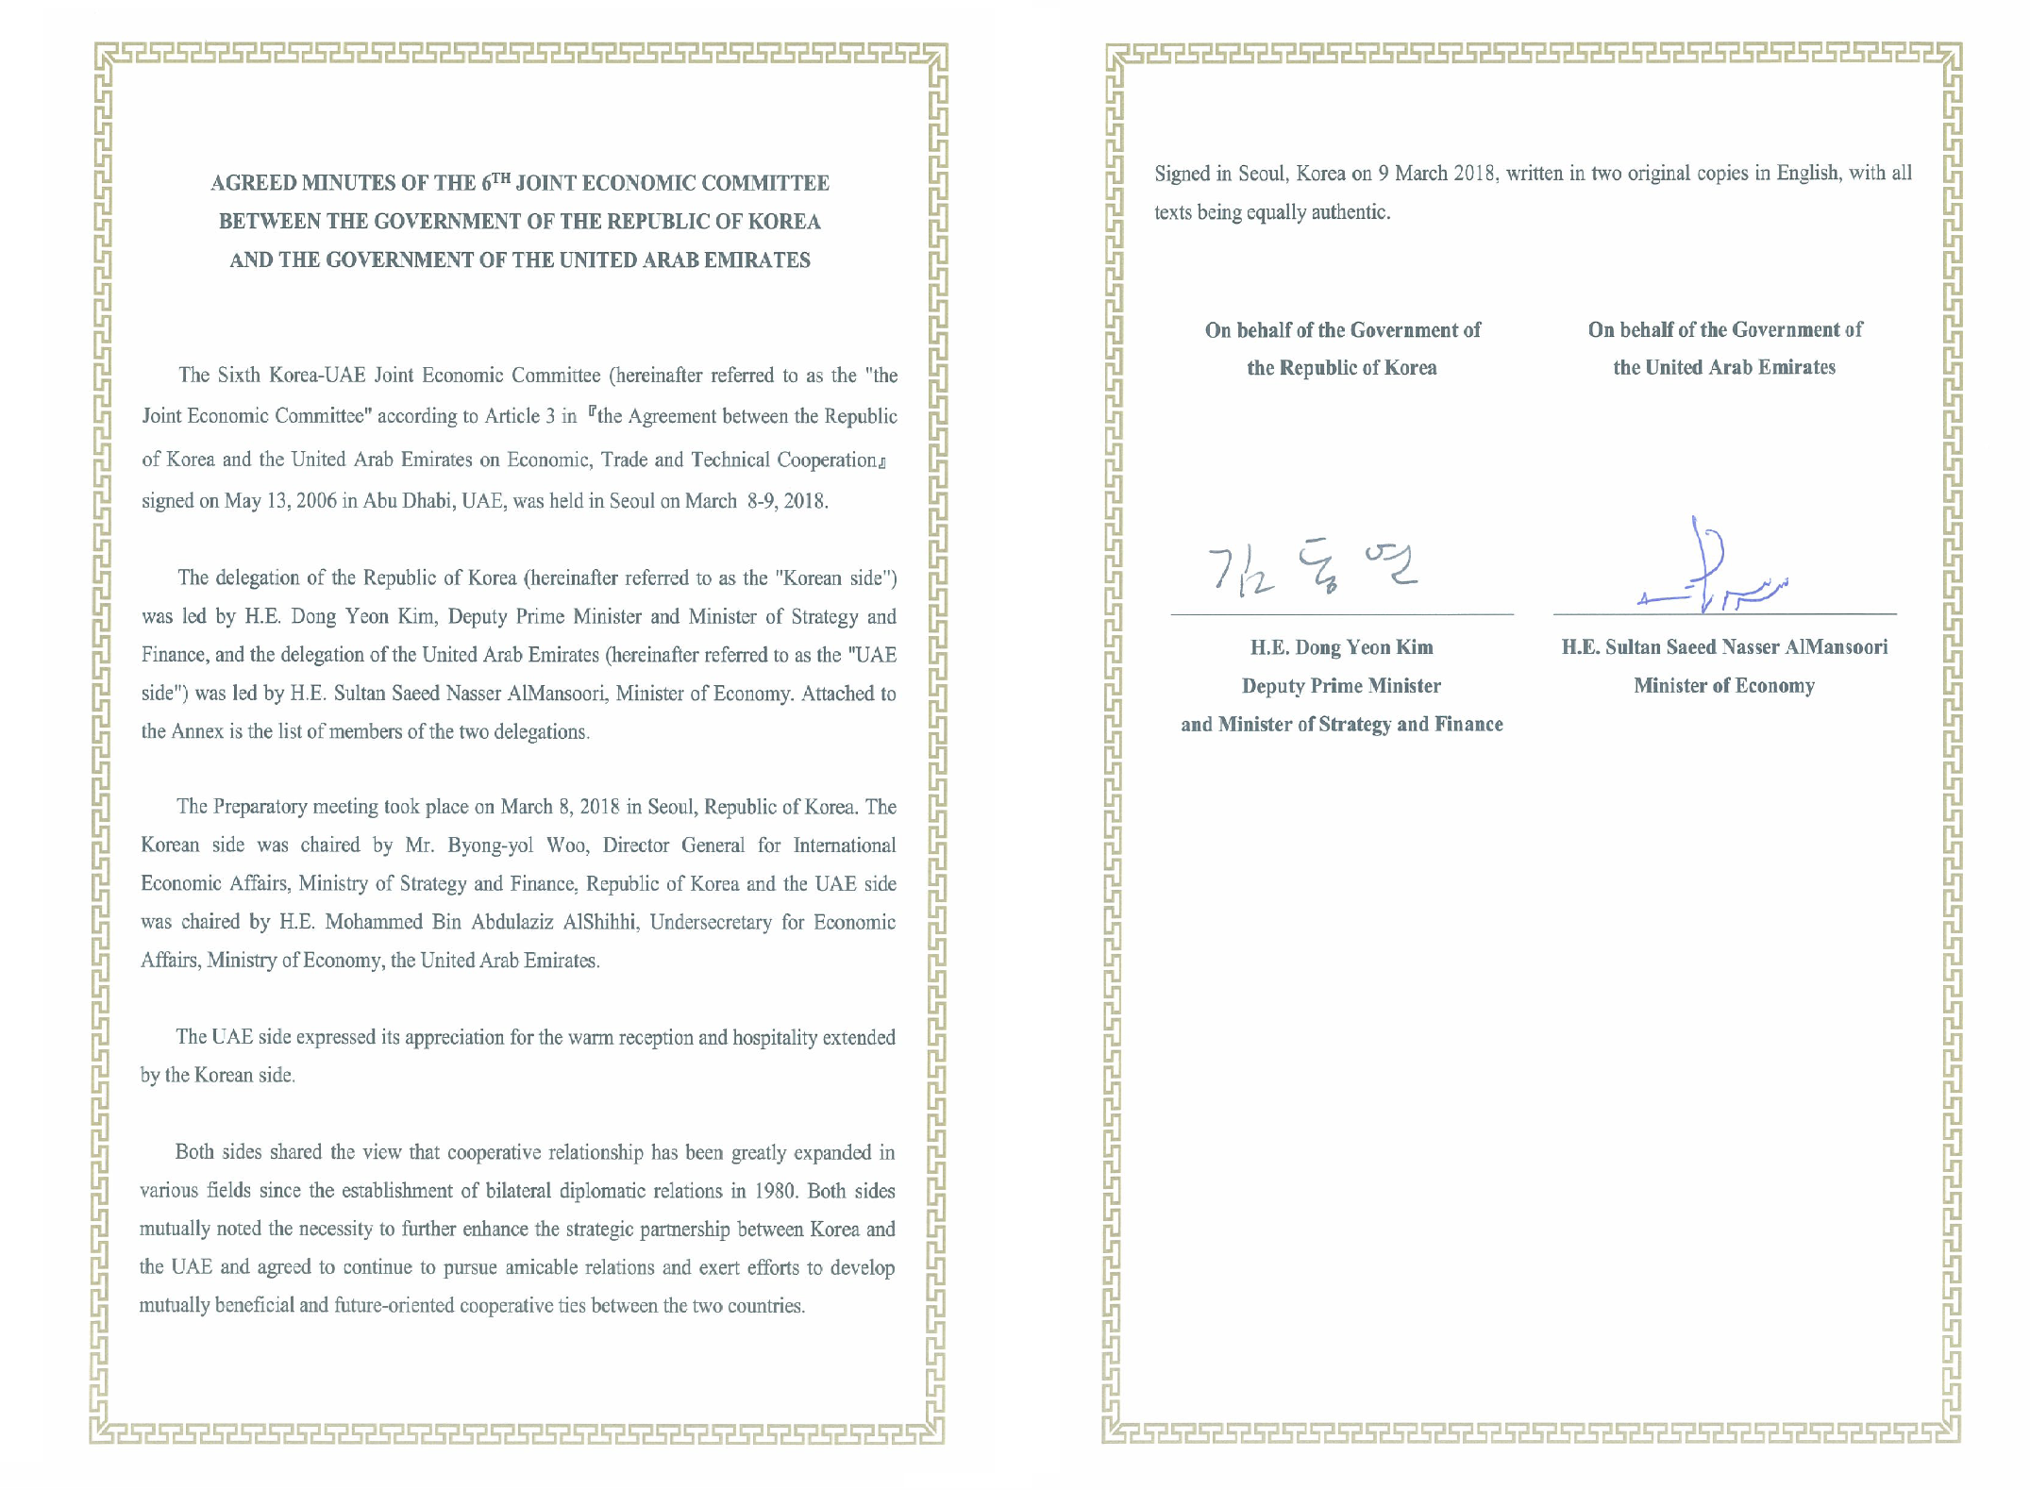KBSI’s request for official approval document from the government of the both countries if KU may wish to convert the center to the lab.
- KUTC cannot be changed without the approval of the governments of both countries. If KU requests a change in center status, it requests approval of the UAE DED, a partner of the Korean Ministry of Science and ICT.
- KUTC is a meaningful international R&D technical center established by mutual agreement in the Korea-UAE Joint Economic Committee and the Joint Science and Technology Committee.
- Korea's Ministry of Science and ICT understands that it is a friendly country that invests for 10 years, but there are many questions about why the center is trying to downgrade it to a joint lab.

